**Wireframe Documentation**

**Travel Data Analysis**

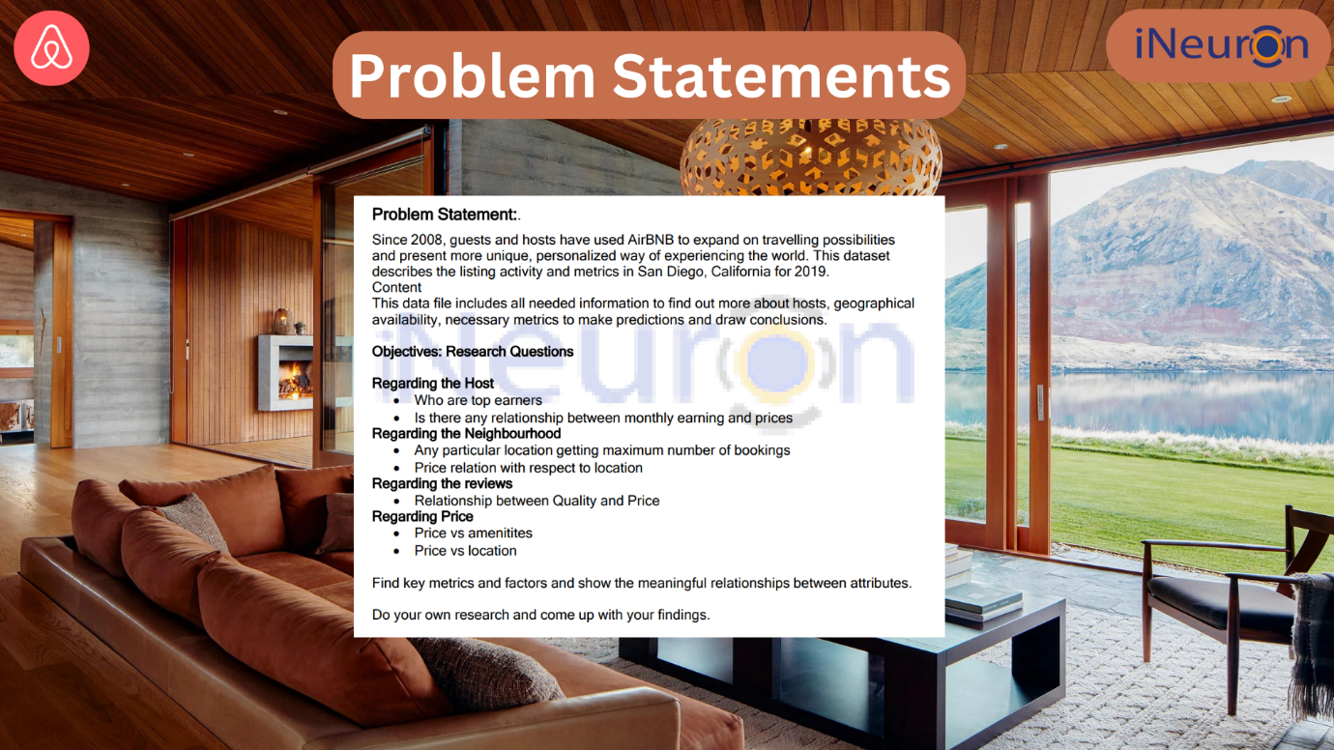

* Commencing the project involves a thorough analysis of the identified problem statements, followed by the formulation of a structured data table to systematically address the project's objectives.
* Subsequently, the data upload process ensues as a pivotal step in populating the designated framework with the necessary information, setting the stage for further analytical and design considerations.

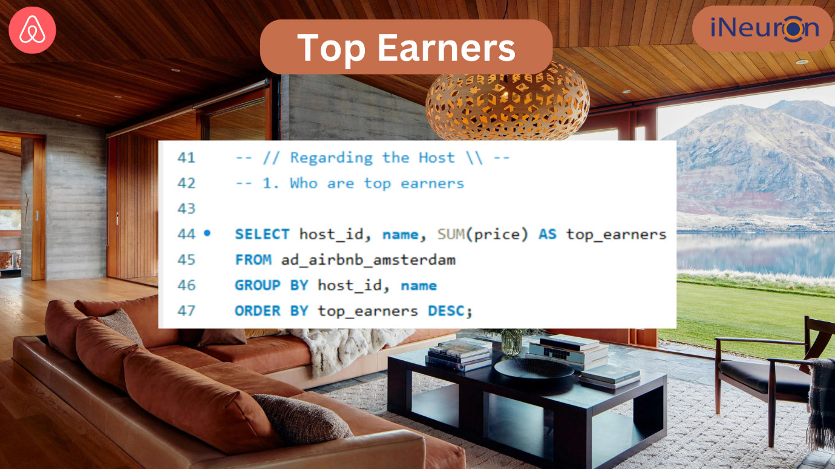

* Within this phase, a comprehensive assessment is conducted to identify and highlight the top earners, playing a crucial role in shaping subsequent decision-making processes and contributing valuable insights to the overall project strategy.

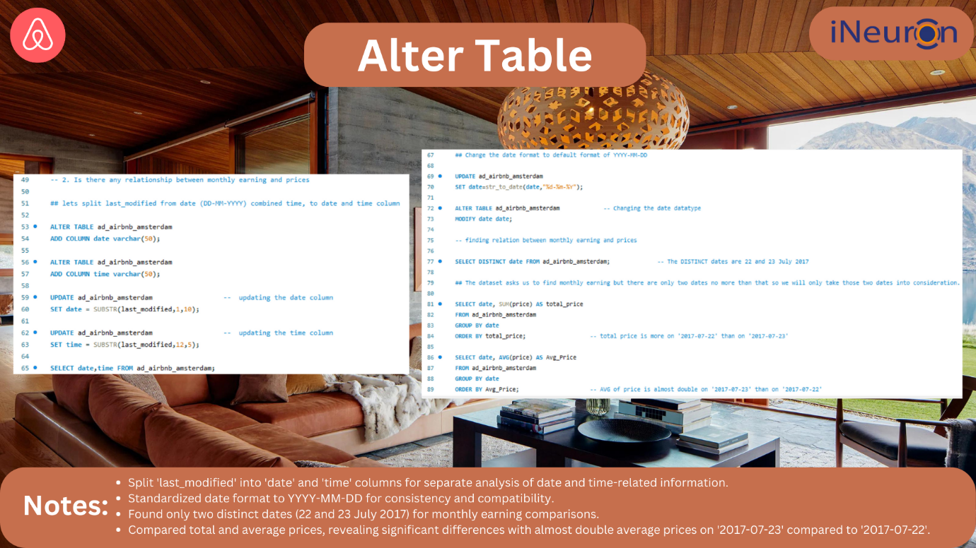

* For the relationship between Monthly earning and prices we alter the table to make necessary changes
* We Split 'last_modified' into 'date' and 'time' columns for separate analysis of date and time-related information.
* Standardized date format to YYYY-MM-DD for consistency and compatibility.
* Found only two distinct dates (22 and 23 July 2017) for monthly earning comparisons.
* Compared total and average prices, revealing significant differences with almost double average prices on '2017-07-23' compared to '2017-07-22'.

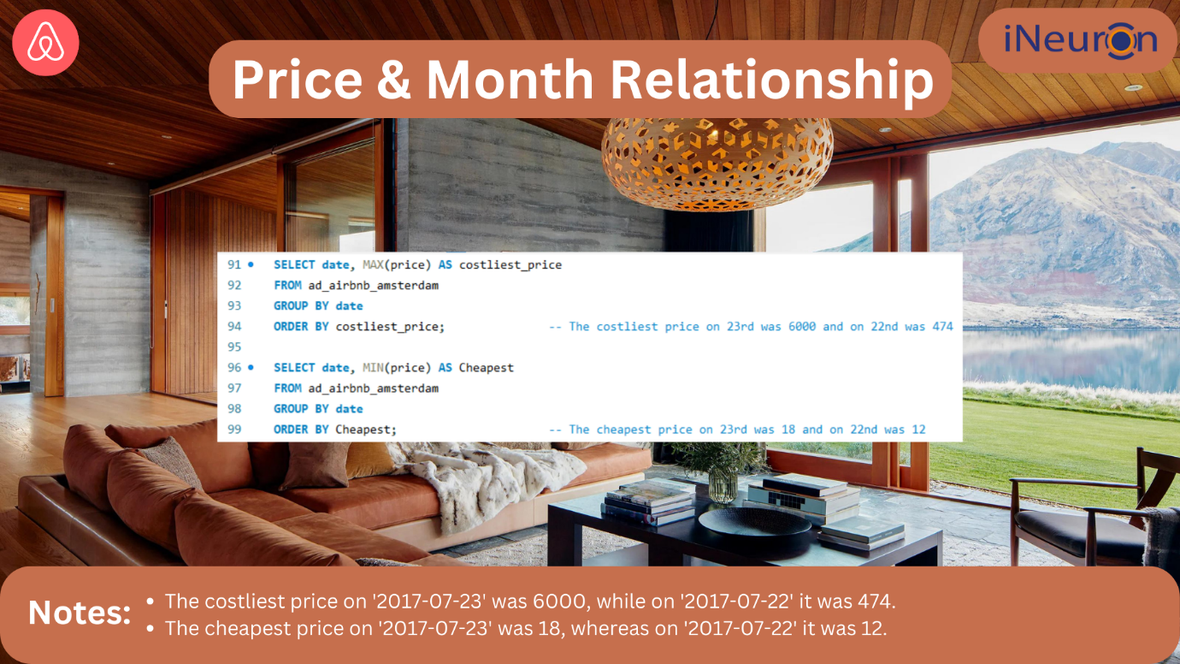

* The costliest price on '2017-07-23' was 6000, while on '2017-07-22' it was 474.
* The cheapest price on '2017-07-23' was 18, whereas on '2017-07-22' it was 12.

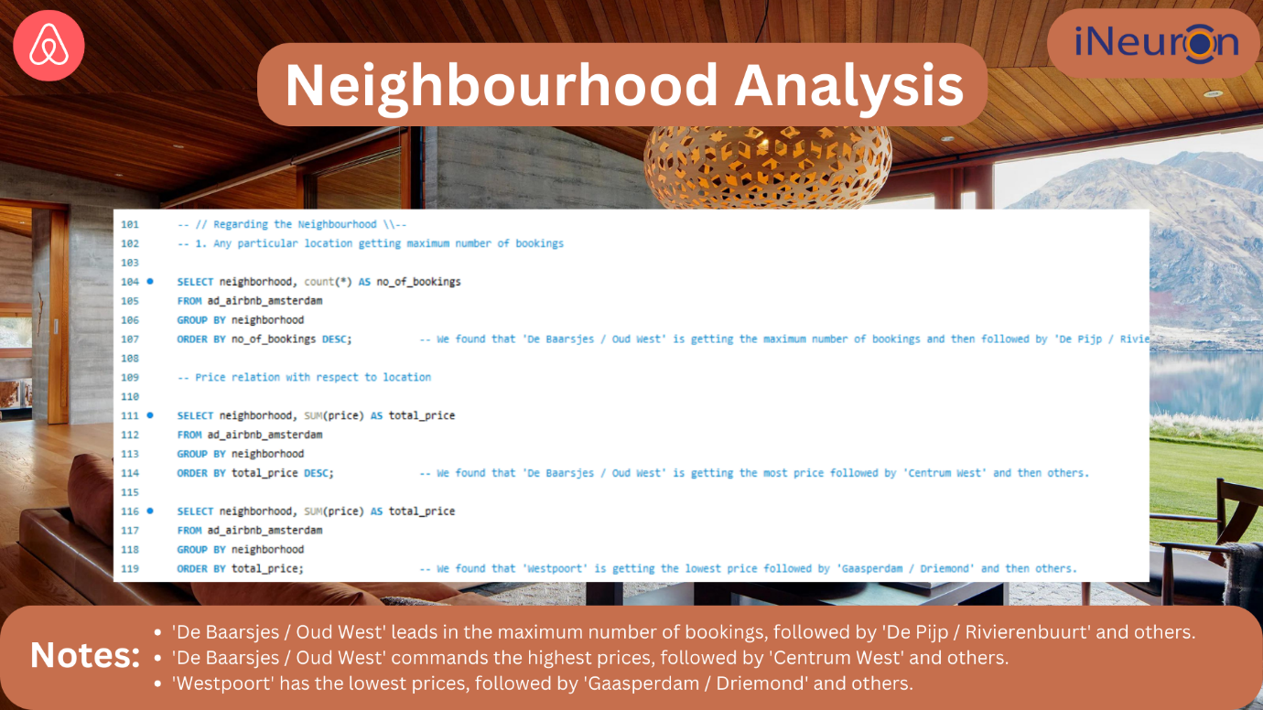

* 'De Baarsjes / Oud West' leads in the maximum number of bookings, followed by 'De Pijp / Rivierenbuurt' and others.
* 'De Baarsjes / Oud West' commands the highest prices, followed by 'Centrum West' and others.
* 'Westpoort' has the lowest prices, followed by 'Gaasperdam / Driemond' and others.

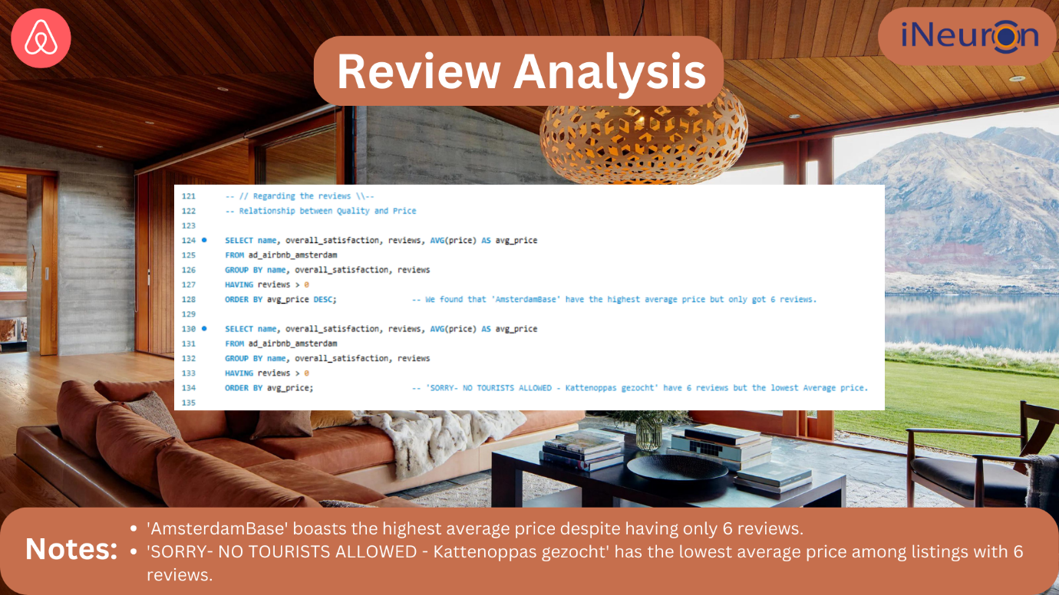

* 'AmsterdamBase' boasts the highest average price despite having only 6 reviews.
* 'SORRY- NO TOURISTS ALLOWED - Kattenoppas gezocht' has the lowest average price among listings with 6 reviews.

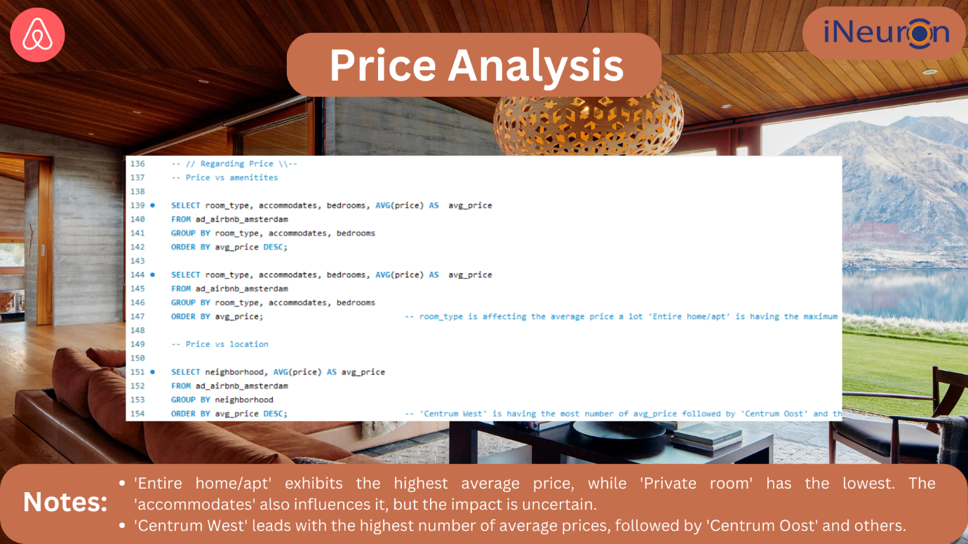

* 'Entire home/apt' exhibits the highest average price, while 'Private room' has the lowest. The 'accommodates' also influences it, but the impact is uncertain.
* 'Centrum West' leads with the highest number of average prices, followed by 'Centrum Oost' and others.

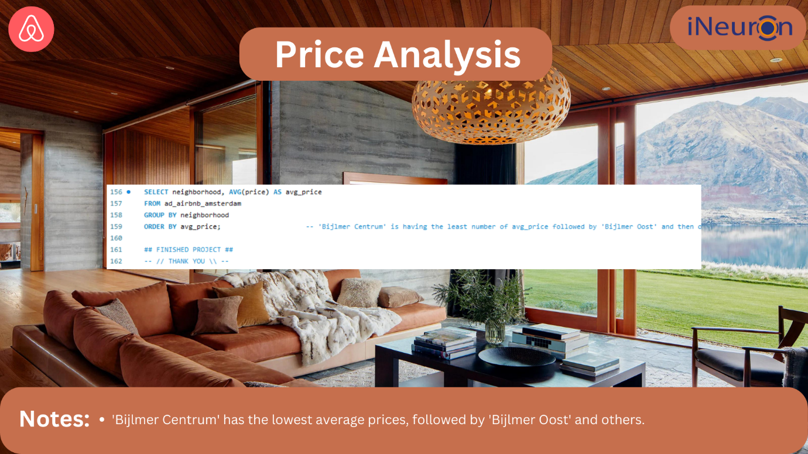

* 'Bijlmer Centrum' has the lowest average prices, followed by 'Bijlmer Oost' and others.